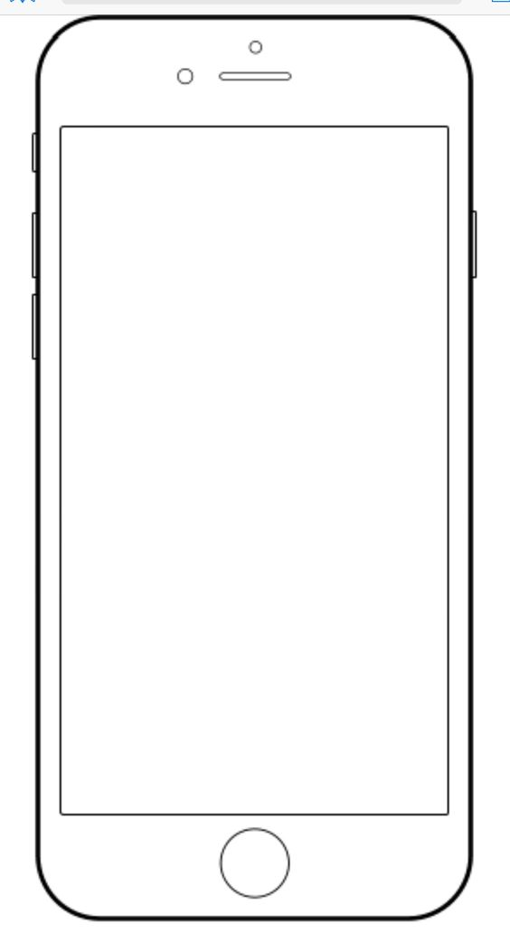 

**Today** 3:55pm

**Today** 3:55pm